FINTECH WITH AI
SALES PERFORMANCE ANALYSIS
USING POWER BI DASHBOARD
A Business Intelligence Project Report
Submitted by
ISWARYA
Department: FinTech with AI
Academic Year 2026 – 2027

Table of Contents
No. | Section | Page
1 | Cover Page | 1
2 | Table of Contents and Abstract | 2
3 | Introduction and Objectives | 3
4 | Dataset Description and Data Model | 4
5 | Power BI Report Link and Overview | 5
6 | Sales Overviews Page | 6
7 | Product and Customer Analysis Page | 7
8 | Sales Dashboard Page (Slicers and Filters) | 8
9 | Tool Tip Page and Key Insights | 9
10 | Conclusion and Future Scope | 10

Abstract
This report presents an interactive sales analytics dashboard developed in Microsoft Power BI as part of the FinTech with AI department curriculum. The dashboard transforms transactional business data — customers, orders, products, categories and employees — into clear visual insights that support faster and better decision-making.
The report is organised into four pages: Sales Overviews, Product and Customer Analysis, Sales Dashboard and a Tool Tip page. Together they present key performance indicators such as total sales, total orders, total quantity sold, number of customers, total freight and average freight, along with trend, category-wise, employee-wise and country-wise analysis.
Screenshots of each report page are included in this document, together with the shareable Power BI link, so that the reader can view and interact with the live dashboard.

1. Introduction and Objectives

1.1 Introduction
Data-driven decision making is at the heart of modern financial technology. Organisations generate large volumes of sales and transaction data every day, but raw data alone has little value until it is cleaned, modelled and presented in a form that decision makers can understand at a glance.
Microsoft Power BI is a leading business intelligence tool that connects to many data sources, builds relational data models, defines calculations using DAX measures, and publishes interactive reports. This project uses Power BI to analyse sales performance and to demonstrate how analytics supports business and FinTech applications.

1.2 Objectives of the Project
- Import and model sales data from multiple related tables in Power BI.
- Create DAX measures for total sales, total orders, total quantity sold, customers and freight.
- Design interactive visuals — cards, line, column and bar charts, and tables.
- Add slicers for year, country and product category to enable dynamic filtering.
- Build a tool tip page that gives quick context when hovering over a visual.
- Publish the report and share it through a Power BI link.

1.3 Scope
The scope covers data modelling, measure creation, visual design and report publishing. The analysis focuses on sales performance across time, product categories, employees, products and customer countries.

1.4 Tools Used
Tool | Purpose
Microsoft Power BI Desktop | Data modelling, DAX measures and report design
Power BI Service | Publishing and sharing the report through a link
Microsoft Word | Preparing this project report

2. Dataset Description and Data Model
The dashboard is built on a relational sales dataset made up of several connected tables. Each table stores one type of business information, and relationships between them allow measures to be sliced by any dimension.

2.1 Tables Used
Table | Description
customers | Customer details including country; used for customer counts and country-wise analysis.
orders | Order transactions including order date and freight; used for the monthly order trend.
products | Product names and details; used in the product-level table.
categories | Product category names; used for category-wise sales and slicers.
employees | Employee names; used to compare orders handled by each employee.

2.2 DAX Measures Created
Measure | Meaning
Total sales | Total revenue generated from all sales
Total order | Total number of orders placed
Total Quatity sold | Total number of product units sold
Number of customers | Count of distinct customers
Total freight | Sum of freight (shipping) charges
Average freight | Average shipping cost per order

2.3 Data Model (Screenshot)
Paste the Model view from Power BI Desktop below to show the relationships between tables.
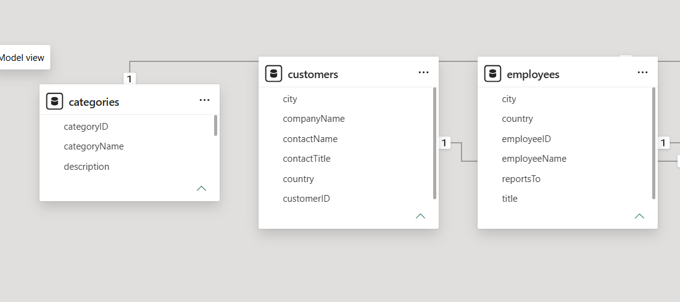

3. Power BI Report Link and Overview
The complete interactive report has been published to the Power BI Service. The reader can open the link below to explore all pages, apply slicers and hover over visuals for tool tips.

3.1 Report Pages
No. | Page Name | Content
1 | SALES OVERVIEWS | Six KPI cards, monthly order trend, sales by category, orders by employee
2 | PRODUCT AND CUSTOMER ANALYSIS | Product table with category, sales and quantity; customers by country
3 | SALES DASHBOARD | Complete dashboard with KPI cards, charts and three slicers
4 | TOOL TIP | Hover page showing total orders, sales and quantity sold

4. Sales Overviews Page
The first report page gives management a one-glance summary of business performance. Six KPI cards across the top show headline numbers, while three charts below break the data down by time, category and employee.

4.1 Visuals on this Page
- KPI Cards: Average freight, Total order, Total freight, Number of customers, Total sales and Total quantity sold.
- Line Chart: Total orders by month, showing seasonality and growth trends.
- Clustered Column Chart: Total sales for each product category.
- Clustered Bar Chart: Total orders handled by each employee

4.2 Screenshot

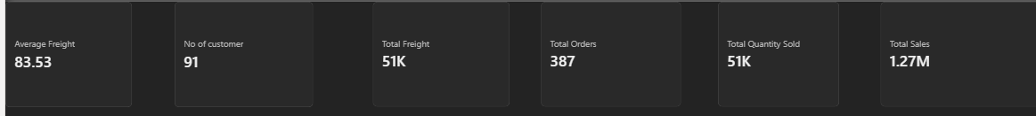

4.3 Observations
Write 2–3 lines here on the highest sales category, the peak order month and the top-performing employee, based on your dashboard values.

5. Product and Customer Analysis Page
This page drills into products and customers. The table lists every product with its category, total sales and total quantity sold, so the best- and worst-performing products can be identified quickly. The bar chart shows how many customers come from each country.

5.1 Visuals on this Page
- Table: Product name, category name, total sales and total quantity sold.
- Clustered Bar Chart: Number of customers by country.

5.2 Screenshot
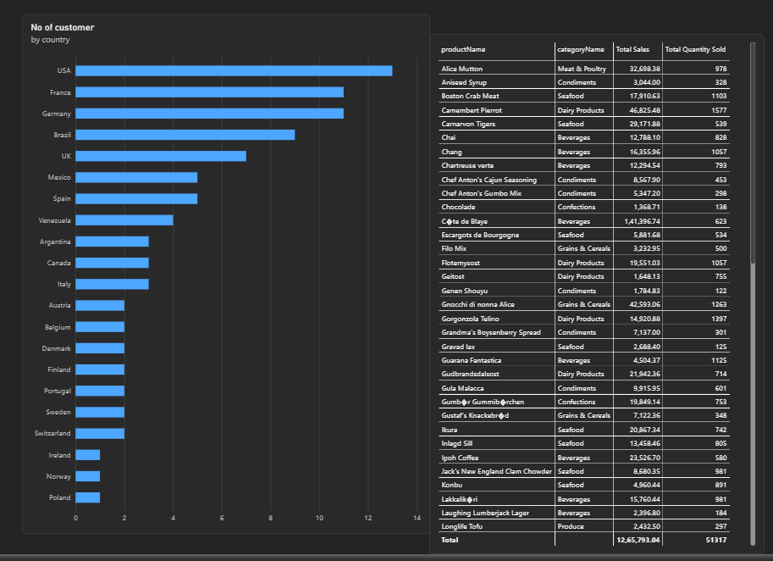

.

6. Sales Dashboard Page
The Sales Dashboard combines all key KPIs and charts on a single canvas and adds interactivity through three slicers. Selecting a value in any slicer instantly updates every visual on the page.

6.1 Slicers and Interactivity
Slicer | Function
Year | Filters all visuals to a selected year from the order date hierarchy
Country | Filters the dashboard to customers from a chosen country
Category Name | Filters the dashboard to a selected product category

6.2 Screenshot
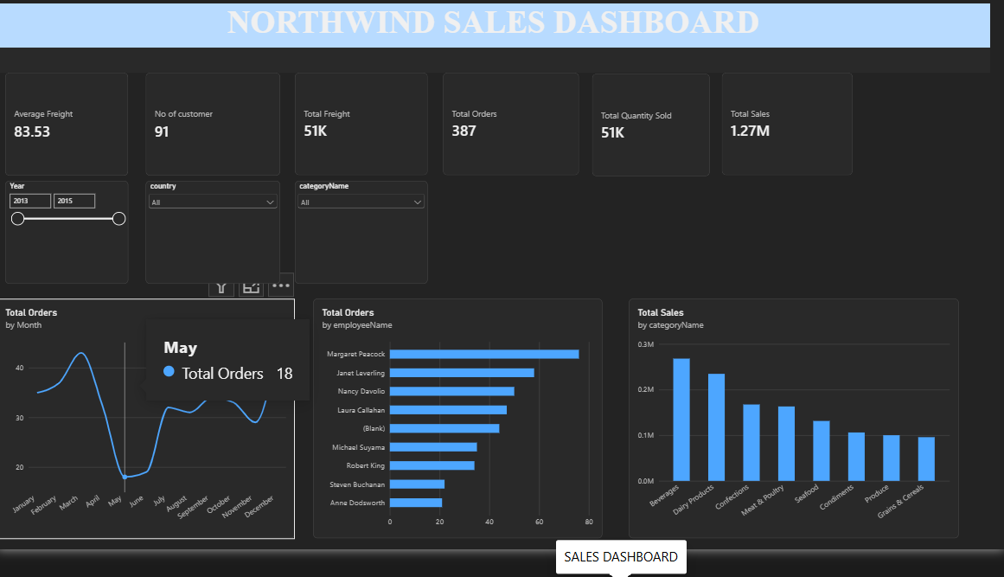

6.3 Observations
Write 2–3 lines here describing how the numbers change when you apply a slicer (for example, a particular year or country).

7. Tool Tip Page and Key Insights
A tool tip page is a small hidden report page that appears when the user hovers over a visual. This report's tool tip page shows three cards — Total order, Total sales and Total quantity sold — giving extra context without cluttering the main dashboard.

7.1 Screenshot
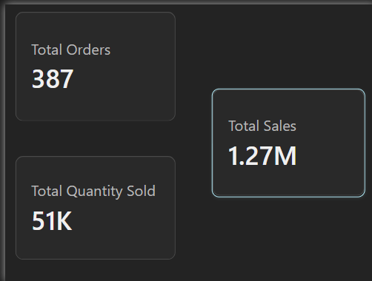

7.2 Screenshot of Tool Tip in Action
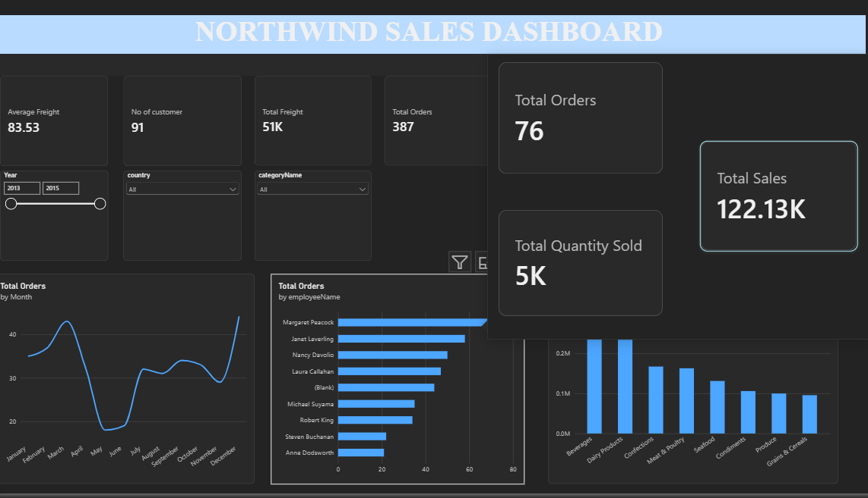

7.3 Key Insights
- Monthly order trends help identify peak and low-demand periods for planning.
- Category-wise sales show which product lines generate the most revenue.
- Employee-wise orders highlight workload distribution and top performers.
- Country-wise customers reveal the strongest and weakest markets.
8. Conclusion and Future Scope

8.1 Conclusion
The project successfully demonstrates how Power BI can convert multi-table sales data into an interactive, easy-to-understand dashboard. By combining DAX measures, appropriate chart types, slicers and a tool tip page, the report lets users move from a high-level summary to detailed product, customer and employee analysis within a few clicks.
The published link allows stakeholders to explore the data on their own, which makes the dashboard a practical tool for monitoring sales performance and supporting business decisions.

8.2 Relevance to FinTech with AI
Business intelligence is a foundation for FinTech and AI solutions. The same data modelling and visualisation skills apply to financial transactions, customer analytics, risk monitoring and revenue tracking. Clean, well-modelled dashboards also provide the base on which AI features such as forecasting, anomaly detection and automated insights can be added.

8.3 Future Scope
- Add forecasting visuals to predict future sales and orders.
- Use Power BI AI visuals such as Key Influencers and Decomposition Tree.
- Connect to live data sources with scheduled refresh.
- Add row-level security so each user sees only relevant data.
- Integrate Copilot / Q&A for natural-language questions on the data.

8.4 References
- Microsoft Power BI documentation – learn.microsoft.com/power-bi
- DAX Guide – dax.guide
— Report prepared by ISWARYA, Department of FinTech with AI —

